# Ubuntu 16.04 本地源安装部署文档

# 安装系统

安装ubuntu16.04 server版操作系统

# 环境拓扑

# 更新源

## 3.1 编辑源文件

(Ubuntu 16.04目前tsinghua镜像网站有源更新)

原文件全部清除，清除之前做好备份

**备份文件：**

cp /etc/apt/sources.list /etc/apt/sources.listbak170408

**编辑文件**：

vi /etc/apt/sources.list

添加如下内容：

######################## Tsinghua ##########################################

deb https://mirrors.tuna.tsinghua.edu.cn/ubuntu/ xenial main restricted universe multiverse

deb https://mirrors.tuna.tsinghua.edu.cn/ubuntu/ xenial-updates main restricted universe multiverse

deb https://mirrors.tuna.tsinghua.edu.cn/ubuntu/ xenial-backports main restricted universe multiverse

deb https://mirrors.tuna.tsinghua.edu.cn/ubuntu/ xenial-security main restricted universe multiverse

################################ end config ################################

**执行命令：**

#apt-get update

## 3.2安装软件包

apt-get install apache2 apt-mirror

## 3.3制作本地源

### 1).打开163、sohu、tsinghua网站

<http://mirrors.163.com/.help/ubuntu.html>

<https://mirrors.tuna.tsinghua.edu.cn/help/ubuntu/>

<http://mirrors.sohu.com/help/ubuntu.html>

/etc/apt# vi mirror.list

############### sohu-8.04 ################################

deb http://mirrors.sohu.com/ubuntu/ hardy main restricted universe multiverse

deb http://mirrors.sohu.com/ubuntu/ hardy-security main restricted universe multiverse

deb http://mirrors.sohu.com/ubuntu/ hardy-updates main restricted universe multiverse

deb http://mirrors.sohu.com/ubuntu/ hardy-proposed main restricted universe multiverse

deb http://mirrors.sohu.com/ubuntu/ hardy-backports main restricted universe multiverse

deb-src http://mirrors.sohu.com/ubuntu/ hardy main restricted universe multiverse

deb-src http://mirrors.sohu.com/ubuntu/ hardy-security main restricted universe multiverse

deb-src http://mirrors.sohu.com/ubuntu/ hardy-updates main restricted universe multiverse

deb-src http://mirrors.sohu.com/ubuntu/ hardy-proposed main restricted universe multiverse

deb-src http://mirrors.sohu.com/ubuntu/ hardy-backports main restricted universe multiverse

############### end config ################################

完整的文件请单击：

### 2).安装screen

apt-get install screen

此命令是ssh会话断线后命令依旧在后台运行

screen –ls查看当前运行进程

screen –d 离线并中断执行。

screen –r 恢复离线的

screen –wipe是移除

具体的参数使用请查手册。

### 3).开始下载源包

screen apt-mirror



以上状态说明源引导文件已经开始下载。说明源配置成功。

### 4).查看引导文件存放位置

/var/spool/apt-mirror/skel

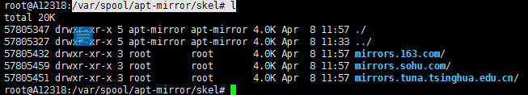

### 5).查看网卡状态

dmesg | grep eno1

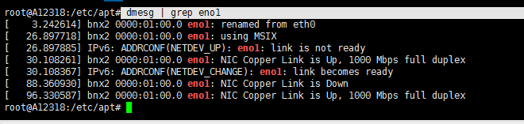

说明是用千M网卡在运行。

### 6).查看源文件存放路径

/var/spool/apt-mirror/mirror#

### 7).查看源是否在下载中

如果看当前如下页面显示，表示源文件在下载中，文件大小169.7GB，下载过程时间长。

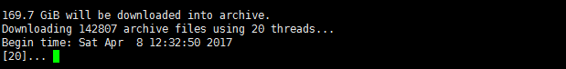

# 制作局域网本地源

## 4.1发布本地源

将下载的源文件目录软链接到apache2网站根目录下

ln –s /var/spool/apt-mirror/mirror/ /var/www/html

## 4.2重启Apache服务

/etc/init.d/httpd restart

# 客户端更新源

## 5.1修改配置文件：

文件名：/etc/apt/souces.list

deb [arch=amd64] http://192.168.21.225/163/ trusty main restricted universe multiverse

deb [arch=amd64] http://192.168.21.225/163/ trusty-security main restricted universe multiverse

deb [arch=amd64] http://192.168.21.225/163/ trusty-updates main restricted universe multiverse

deb [arch=amd64] http://192.168.21.225/163/ trusty-proposed main restricted universe multiverse

deb [arch=amd64] http://192.168.21.225/163/ trusty-backports main restricted universe multiverse

deb-src [arch=amd64] http://192.168.21.225/163/ trusty main restricted universe multiverse

deb-src [arch=amd64] http://192.168.21.225/163/ trusty-security main restricted universe multiverse

deb-src [arch=amd64] http://192.168.21.225/163/ trusty-updates main restricted universe multiverse

deb-src [arch=amd64] http://192.168.21.225/163/ trusty-proposed main restricted universe multiverse

deb-src [arch=amd64] http://192.168.21.225/163/ trusty-backports main restricted universe multiverse

## 5.2客户端源更新

执行命令：apt-get update

## 5.3查看是否可用

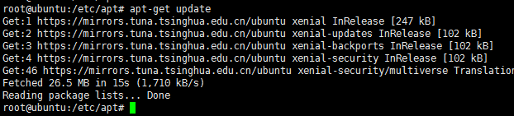

执行后为上图所示状态为正常